O(B)IA: mean that the B was already on the board
BoTAn(I)ZE: the o and n were blanks and the I was already on the board
“8G”, “9E” are a board coordinates
+50/68: the first is the score for the play, the second number is the total

Game 1:
Jim Kramer v. RealNetworks Scrabble
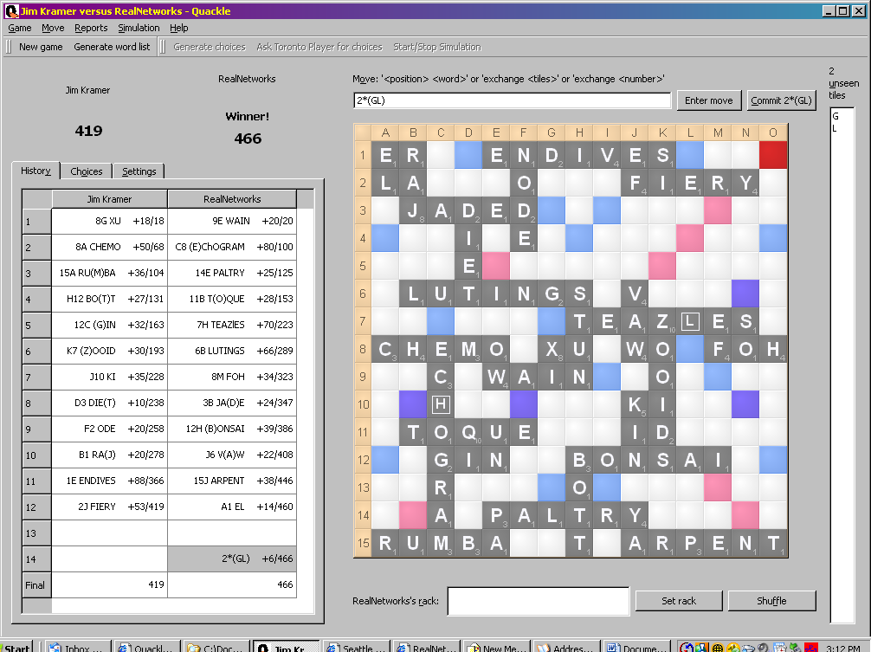

Game 2:
Jim Kramer v. RealNetworks Scrabble
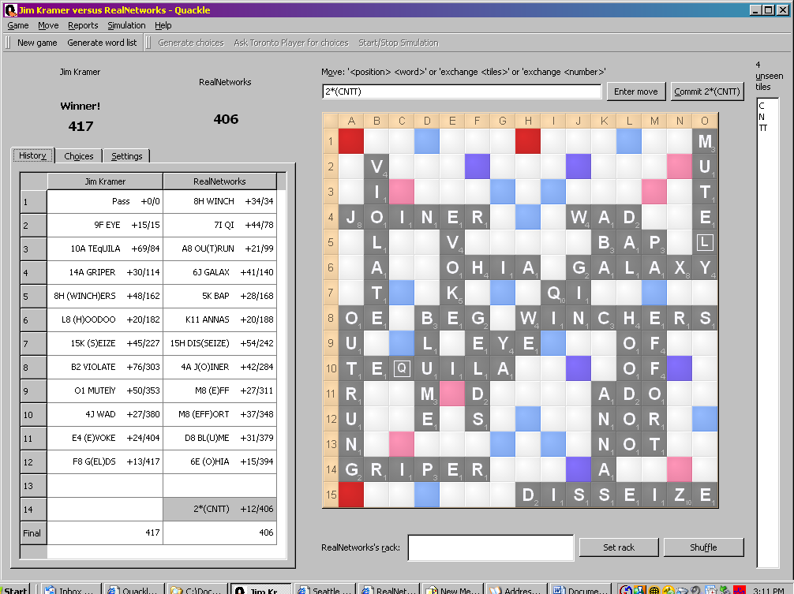

Game 3:
Jim Kramer v. RealNetworks Scrabble
